**Lakewood Lutheran Dress Code 2026/2007**

**(allowed 25/26 School Year)**

**Boys and Girls:**

**\*Black or Purple LLS Polos:**

Sweaters: Knit only

Black, White, Purple, Gray

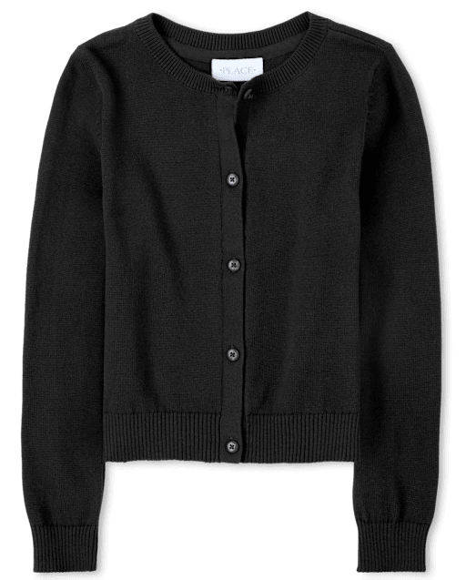

Shorts (Weather appropriate):

Khaki or Black shorts

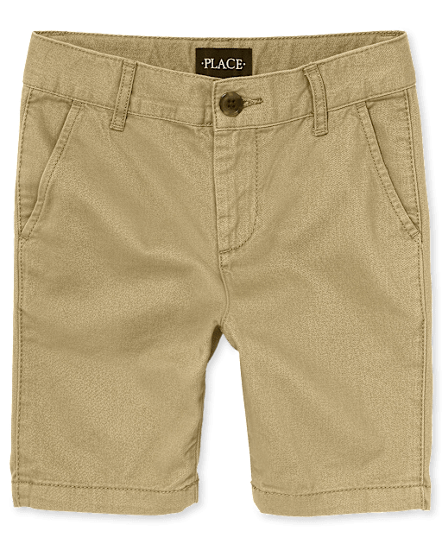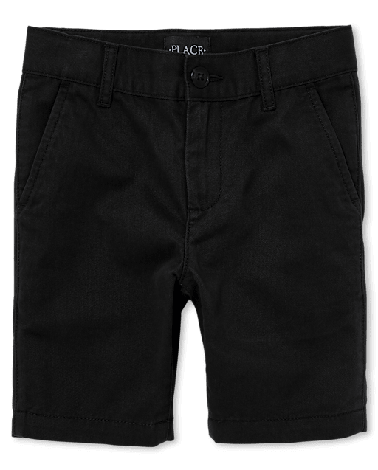

**Purchased from the Office**

School Year Themed Spirit Wear

“Make a joyful Noise”

Purchased through the Office

Once available

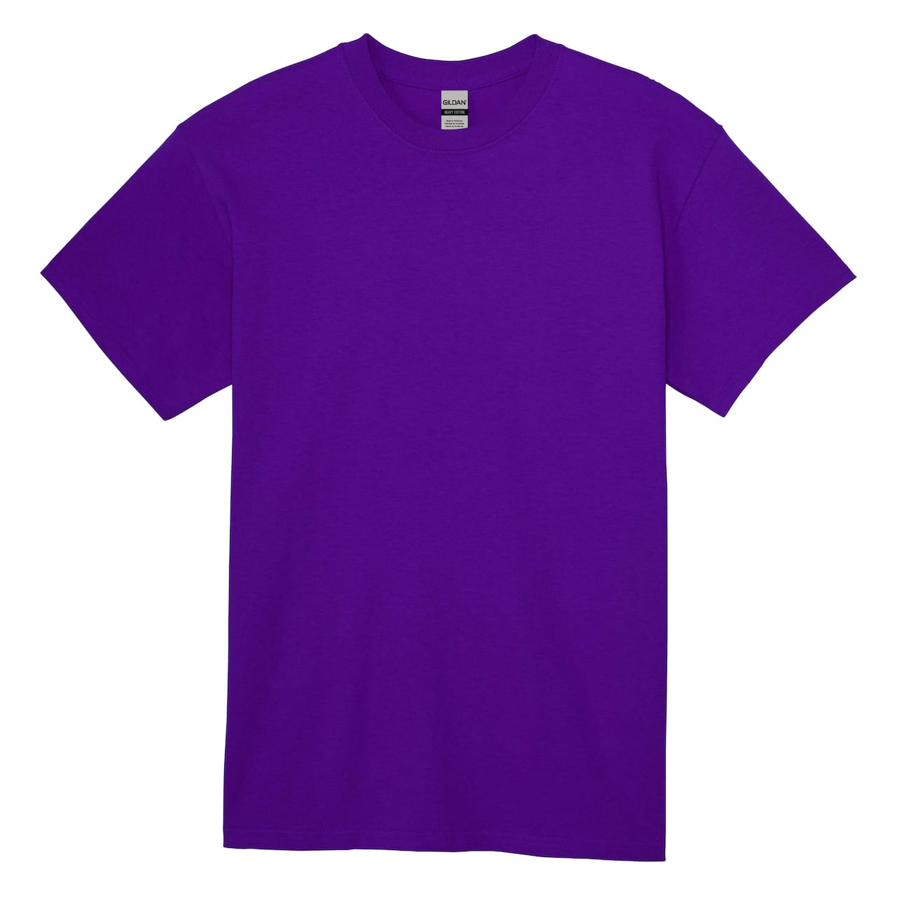

Shoes: Solid Color- No Crazy designs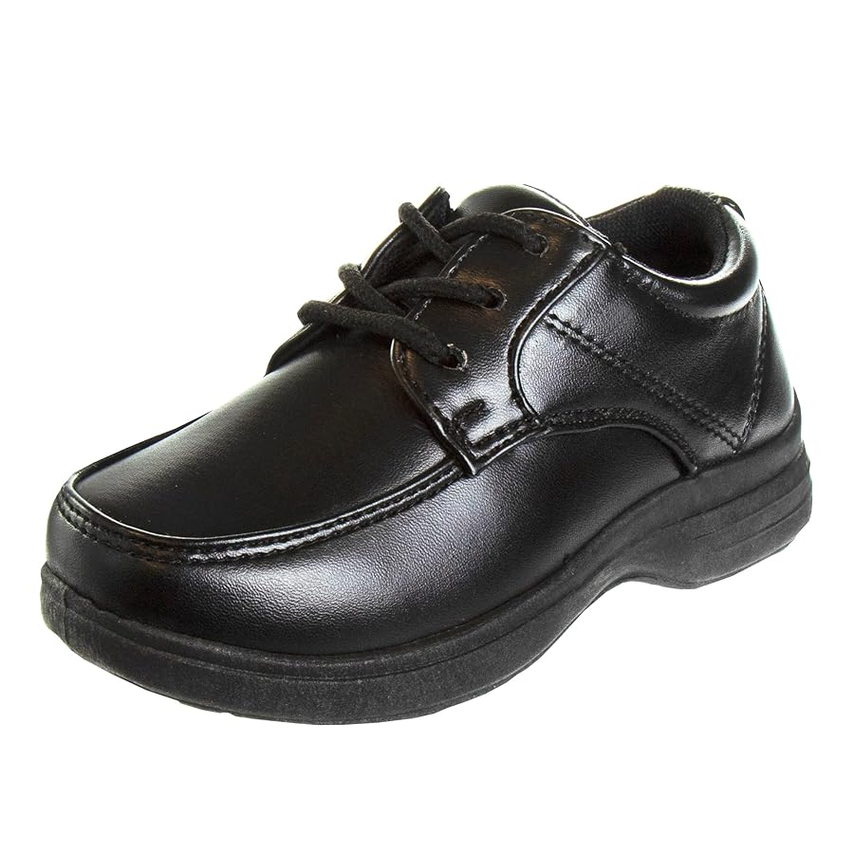 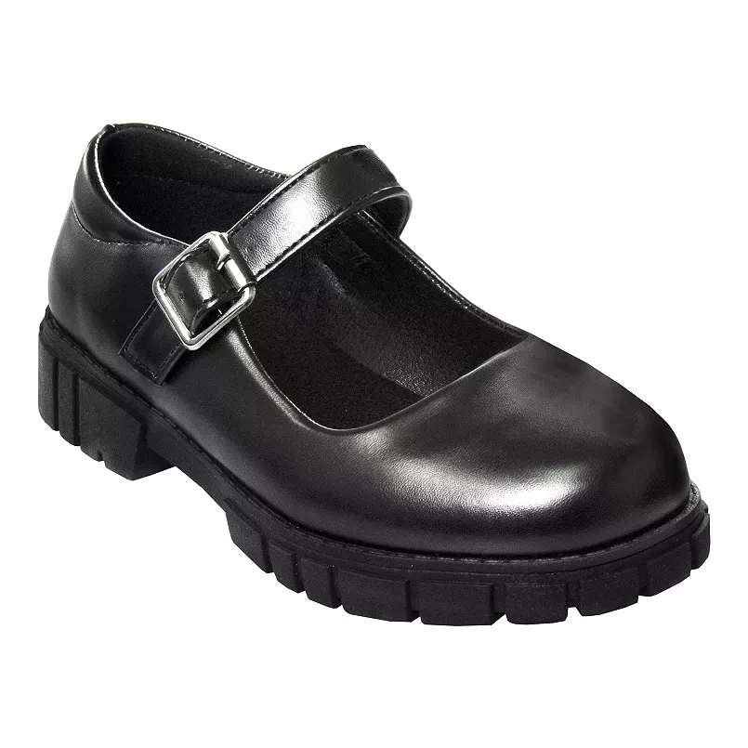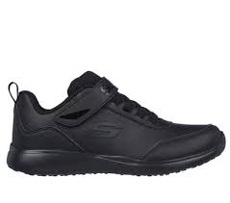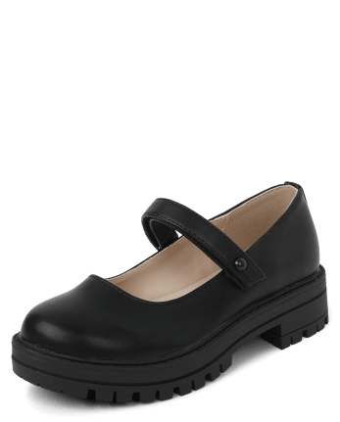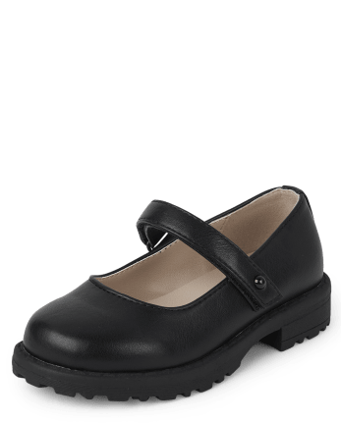

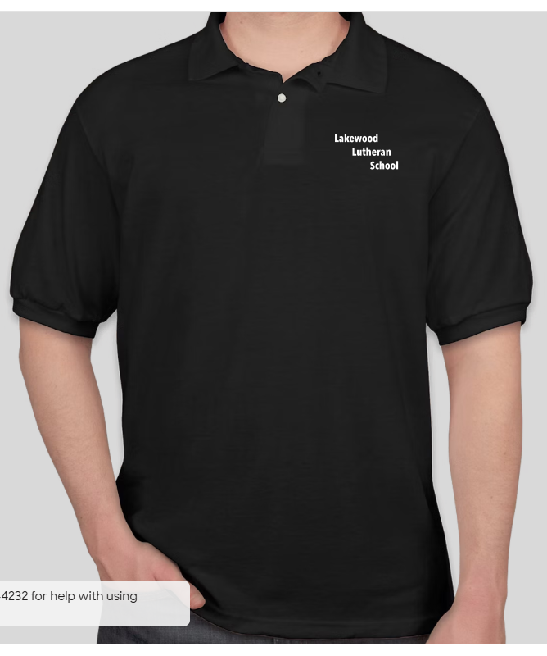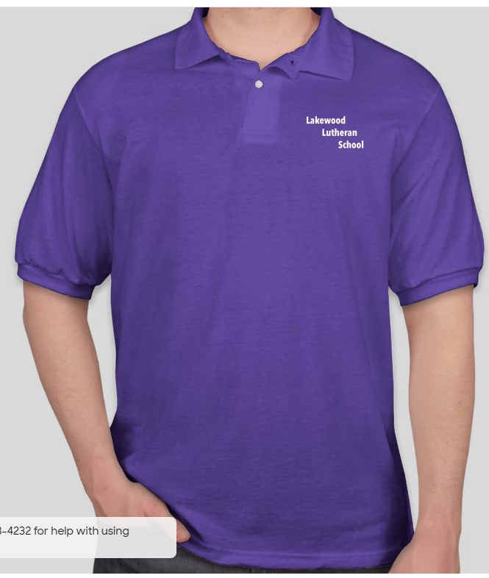

Pants:

Khaki or Black

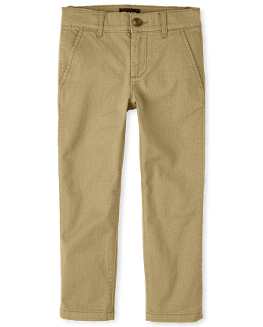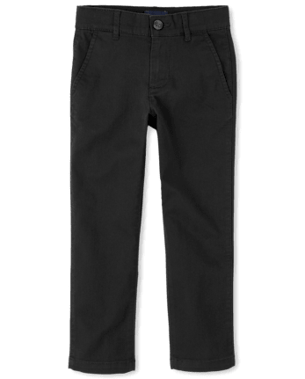

Previously purchased LLS Hoodies are acceptable cold-weather wear.

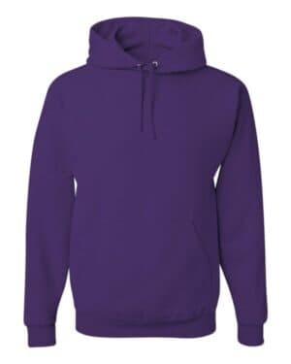

Girls only:

Skirts/Jumpers (Modesty Shorts are required)

Black or Khaki colors

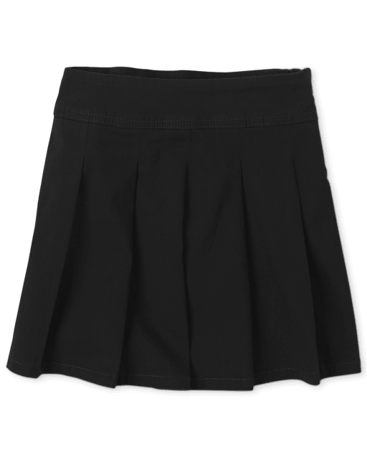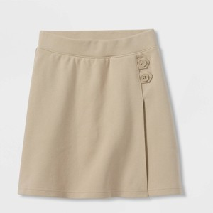 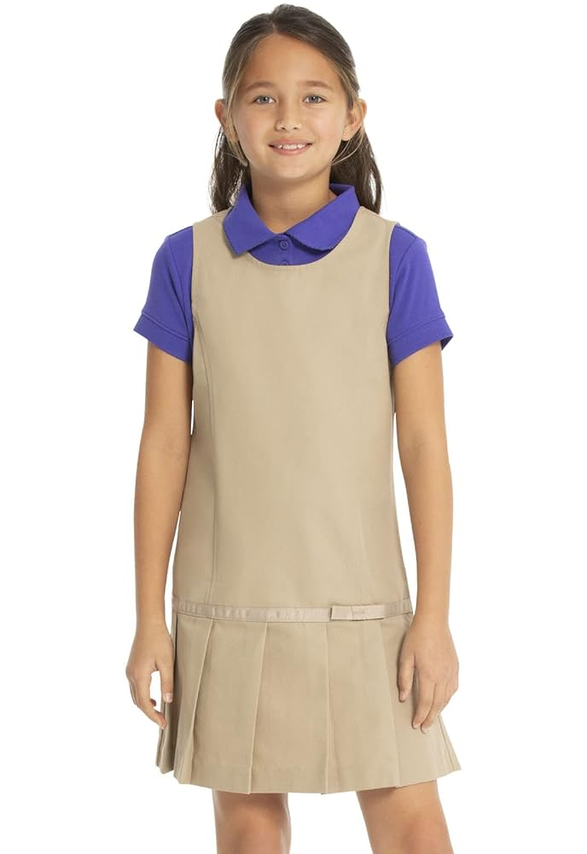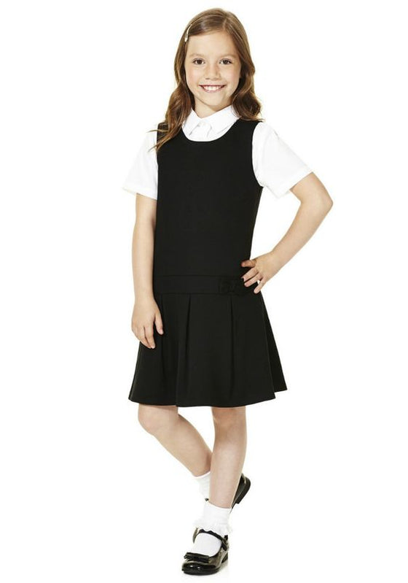

**PURPOSE OF HAVING A DRESS CODE:**

Student dress is primarily the duty and responsibility of the parents, yet is also a valid concern of the school environment. Parents are encouraged to provide acceptable options within the code for children as they select what they wear. All clothing worn should be clean, neat, not faded, and in good repair. Therefore, the following are some reasons for deciding on a dress code for our students:

1. To eliminate worldly competition as expressed through clothing. (John 17:16)
2. To present an attractive appearance that is pleasing to the Lord. (2 Cor. 5:17)
3. To diminish socio-economic distinctions through clothing. (Proverbs 11:2)
4. To eliminate drawing attention to oneself through extremes in style. (1 Peter 3:4)
5. To avoid immodesty. (1 Cor. 8:9)

At all times, students will be expected to maintain LLS’s high standards and to exhibit self-control in areas of personal cleanliness, neatness, and overall physical appearance. The dress code is in effect for all school days and related school events (field trips, etc.) unless notified otherwise.

**DRESS CODE DESCRIPTION:**

**Acceptable Shirt Colors:** Black or Purple LLS Polos; School year Themed Spirit shirt

**Undershirts may be worn, **BUT** must be black or purple. **

**Sweaters:** Pull-over or button-up, must be knit. Colors: Black, white, purple, gray

*NO FLEECE or SWEATSHIRT FABRIC*

**Acceptable Shorts and Pants Colors:** Khaki, black. No athletic shorts or sweat pants

**Acceptable Styles:** Regular, trouser-style pants. NO “SKINNY”, “LEGGINGS”, or “SWEATPANT” style.

**\***Shorts allowed until November 1 and after April 1. Shorts must come to mid-thigh. *

**Acceptable Skirt and Jumper Colors:** Khaki, black**. Modesty shorts are required under all skirts/jumpers.**

**Acceptable Skirt Styles:** Length: 2 inches above the knee, without excess adornments/embellishments.

* Solid uniform colored (white, black, flesh-toned) leggings/tights may be worn UNDER a skirt *

\***Modesty shorts are required under all skirts/jumpers. \***\*

**Shoes:** Solid color, closed-toe dress or tennis shoe, no more than one accent color. Heels no higher than 1.5 inches. Hiking/sports boots may be worn during the wintertime. \***SOCKS/TIGHTS AT ALL TIMES\***

**Hair:** Natural colors, neat, clean, and out of the eyes. Boys' no longer than shirt collar. No extreme styles.

**Accessories:** Limited jewelry and fashion accessories. No extremes. K-4 no make-up, 5-8 lightly applied make-up.

**Dress Down Days:** Keep clothing God-pleasing and appropriate.

**WHEN IN DOUBT, DON’T WEAR IT!**