

Class Supply Lists 2025/2026

K – 1

- Pencil box (no pouches)
- 24 pack crayons
- Scissors
- Paper towels (2 rolls)
- Baby wipes (2 packs)
- Large divided plates
- (1) 3 inch binder
- Tissues (3 boxes)
- (1) 3 subject wide rule notebook (first grade only)
- Backpack
- Lunch box
- Complete change of clothes in plastic bag labeled with name
- City of Lakewood Library card
- LLS Spirit Shirt ($10) – order quantity and size through school office

Grade 2 – 4

- Scissors
- Tissues (3 boxes)
- Antiperspirant/deodorant (no aerosol/spray)
- (2) Rolls of paper towels
- (1) 3 inch binder
- Small paper plates
- Pencil box
- 24 pack crayons
- (1) 3 subject wide rule notebook
- Complete change of clothes in plastic bag labeled with name
- City of Lakewood Library card
- LLS Spirit Shirt ($10) – order quantity and size through school office

Grade 5 – 8

- (1) zippered pouch or pencil box
- (3) College rule notebook paper
- (3) Tissues
- Pair athletic shoes and clothes to be kept in locker for gym
- Antiperspirant/deodorant (no aerosol/spray)
- (2) Rolls of paper towels
- 12 count colored pencils
- City of Lakewood Library card
- LLS Spirit Shirt ($10) – order quantity and size through school office

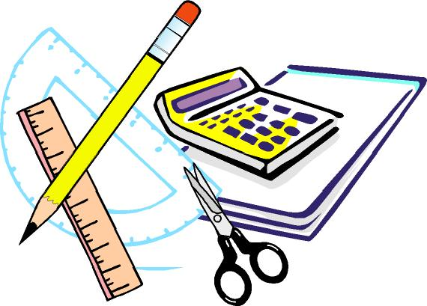

Having a second set of
supplies at home in a special area would be a great idea!

This helps create a space to complete and succeed in homework activities.

Thank you in advance for helping us create a positive and well stocked learning environment! ☺

Turn over ☺

These supplies will be provided for your child.

Pencils
Pens (black, red and blue)
Graph paper
Ruler, protractor, pencil compass
Calculator
Large pink erasers
Markers
Colored pencils
Spiral notebooks
Composition books
Glue sticks & liquid glue
Dry erase markers
Highlighters
Folders
Binders (1 ½ in. and/or 1 in.)
Subject dividers
Sticky notes
Plastic spoons, forks, knives
Paper napkins
Paper cups
Hand sanitizer
Liquid hand soap
Disinfecting wipes

If you would like to purchase any of the above supplies, you may.

(But you don’t have to. ☺)

